Learn More & Read Faster: A Handbook of Advanced Reading Strategies for College Success, 4th edition

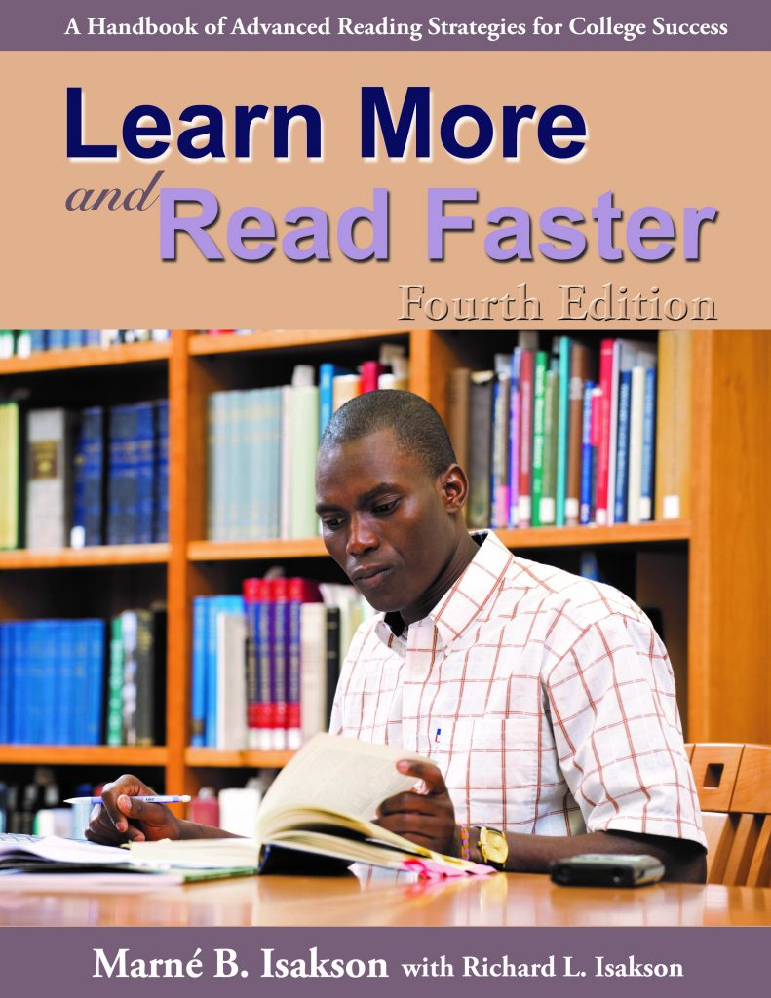

Purpose:
Handle your heavy reading loads in timely ways with solid understanding, metacognitive awareness, good retention, and critical and creative thinking.

Target Audiences:
Upperclassmen who have declared their majors, graduate students, professional school students, diligent underclassmen, and people in careers with lots of reading. This handbook is also used in our online courses and for the self-instructional guide.

Description:
Learn More & Read Faster: A Handbook of Advanced Reading Strategies for College Success teaches 31 academic reading strategies, the 16 deemed essential for "surviving" college reading plus 15 additional strategies for critical and creative reading and in-depth learning such as for close reading, exam reading, and research reading. Each strategy is explained (what, why, how, under what conditions to use it); examples are given; a ThinkSheet is provided for each strategy to guide you through the process initially; and additional useful information is provided such as tips to enhance the strategy, adaptations for reading electronic texts, ways to use it to increase your vocabulary, ways to push through to more scholarly thinking, comments by readers about using it, and figures/tables to increase understanding of the strategy.
The handbook has drills to help you increase your reading rate of academic texts. It also offers suggestions for record keeping to monitor progress; provides eight appendices including shared texts for demonstration and practice, a section about differences in reading processes based on the discipline, our model of the academic reading process; and has an in-depth glossary of 37 key concepts for understanding academic texts on a deep level. The goal of this handbook is to help you take a curious, "creative, critically intelligent, compassionate, and concerned" (K. Bain, 2012, p. 201) approach to learning from intriguing and important texts.
Click here to see Table of Contents for Learn More & Read Faster.
ISBN: 9781611650457 © 2021, 358 pages. Click here for ordering information.

