Surviving College Reading: A Handbook of Essential Reading Strategies for College Success (2nd ed.)
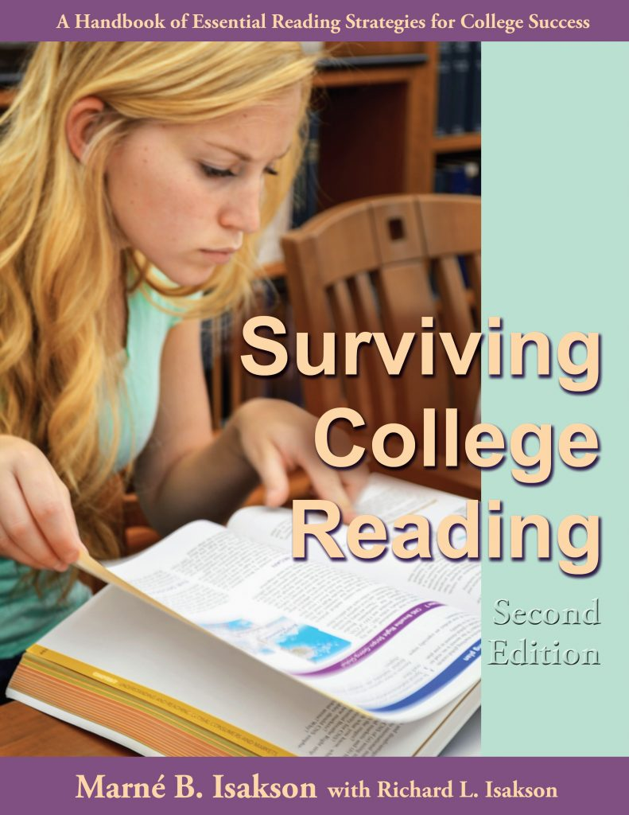

Purpose:
To help readers learn and apply 16 essential strategies with metacognitive awareness to help you complete reading assignments with understanding and retention, and in a timely way.

Target audiences:
College students wanting to learn the essential strategies of academic reading, college-bound high school students, and college populations such as English language learners, academically under-prepared students, or special-needs students. Also useful for tutors and academic advisers for what to suggest to readers who come to academic support centers for help.

Description:
Surviving College Reading: A Handbook of Essential Reading Strategies for College Success teaches 16 academic reading strategies, the strategies that our students say make the biggest different in helping them understand, remember, and finish reading in a timely manner. Each strategy is well explained (What, Why, How, Under What Conditions to use it); examples are given; a ThinkSheet is provided to guide you through the process initially; and additional useful information is provided such as how to adapt the strategy when reading electronic texts, how to apply each strategy to learning the key vocabulary for a course, what readers say about it, tips for using it well, and quotations to enhance understanding. Moreover, six speeding up drills can increase your reading rate of academic texts. The appendix includes an article about how to learn technical vocabulary for the long-term, and the book has an in-depth glossary of 30 key concepts, an understanding of which will enhance your ability to learn from academic texts. The handbook offers instructors record-keeping suggestions to monitor progress and provides some shared texts for demonstration and practice. The goal of this handbook is to help you build the skills and mindset to be a confident and competent learner of your academic texts.
Click here to see Table of Contents for Surviving College Reading

Information:
ISBN: 978-0-74093-259-5 © 2017 212 pages. Click here for ordering information.

